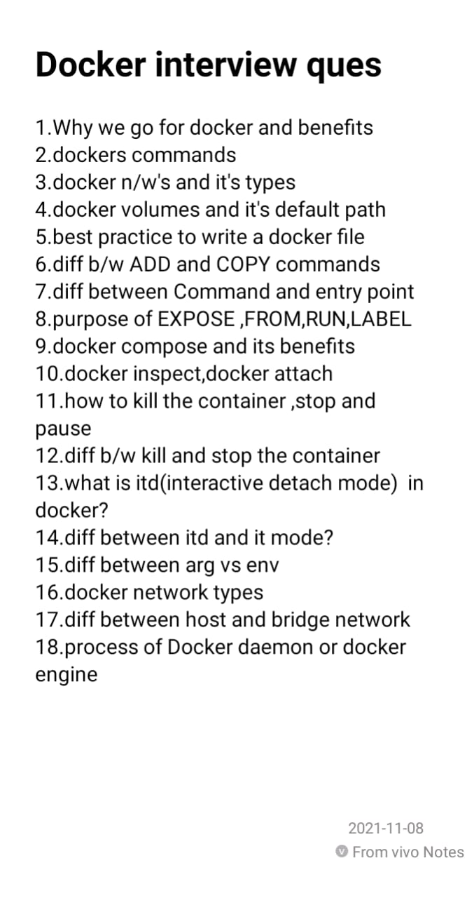

**Difference between the COPY and ADD commands in a Dockerfile**

COPY is a docker file command that copies files from a local source location to a destination in the Docker container.

It only has only one assigned function.

Its role is to duplicate files/directories in a specified location in their existing format.

If we want to avoid backward compatibility, we should use the COPY command.

ADD command is used to copy files/directories into a Docker image.

It can also copy files from a URL

ADD command is used to download an external file and copy it to the wanted destination.

ADD command is less usable than the COPY command.

**difference between command and entrypoint in docker**

**Docker – EXPOSE Instruction**

The **EXPOSE**instruction exposes a particular port with a specified protocol inside a Docker Container.  In the simplest term, the EXPOSE instruction tells Docker to get all its information required during the runtime from a specified Port. These ports can be either TCP or UDP, but it’s TCP by default. It is also important to understand that the EXPOSE instruction only acts as an information platform (like Documentation) between the creator of the Docker image and the individual running the Container